Khairunneeta Mohd Afendy  2015 Singapore Sea Games Gold Medallist. Former National Sailing Athlete from 2008 till 2019. Due to recurrent injury, she had stopped and currently doing part time private coaching to international sailing athletes whom seeking her expertise. Participated in Phuket Kings Cup in December 2022 and won silver medal in ILCA 6 category. "Sailing is a part of my life and I’m really looking forward to be racing in Squib class in Pulau Indah this June". | 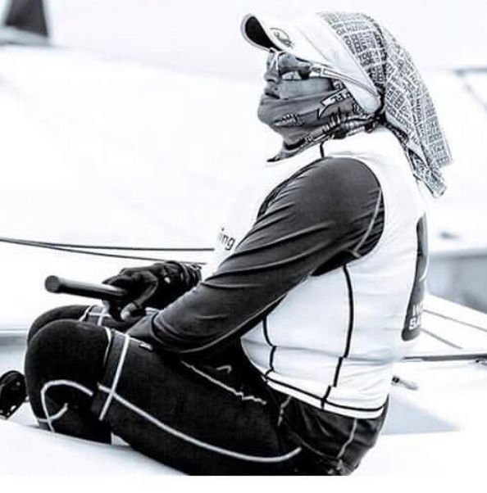
Muhammad Syafizzy bin Ishak
Kedah Sailing Team on the rise sailor. He had won 2nd place in the Langkawi International Regatta in Int 420 category. Well-mannered sailor. He has great level of fitness and is a very hardworking sailing athlete. Participated in the RLYC in January being a part of Team Dash as a bowman. “Never sailed a squib before, I am looking forward to the competition.
Brandan Richard Wright  One of the Kedah Sailing Team pride and an uprising sailor. He is currently sailing in the ILCA 7 category. He represented Kedah in the National Games. His goal is to represent Malaysia in the Olympic games. He’s been training really hard in the ILCA 7 category to make sure he can achieve his goals. | 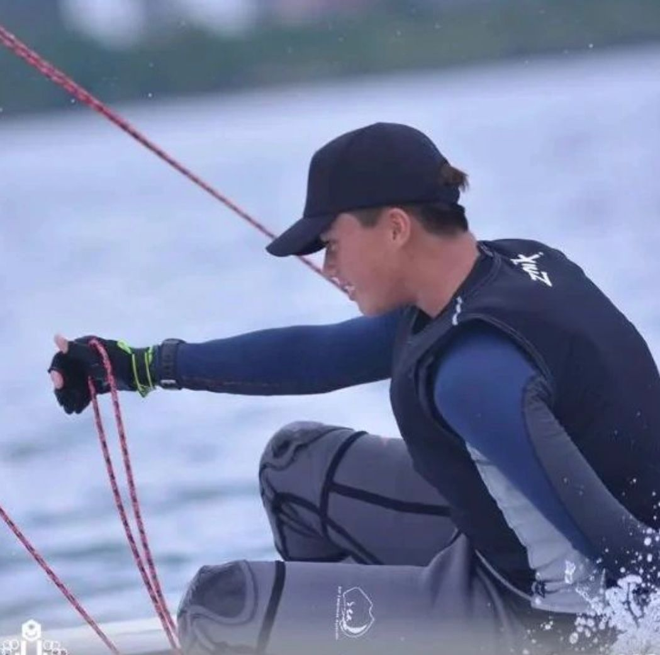
Muhammad Hamka Naufal  Malaysia National sailor sailing in the Int 420 class. Recently, he had won 1st place at the Langkawi International Regatta Perdana 2023, He is currently training full time under the national team. An amazing sailor. Ranking no 1 in Malaysia in the Int 420 category. His goals is to represent Malaysia in various international events such as Youth World Sailing Championship and Asian Sailing Championship. | 